VOLUME 2
QUADRUPED ROBOTICS
Legged Robots | Quadruped Leg Kinematics | Gaits and Locomotion
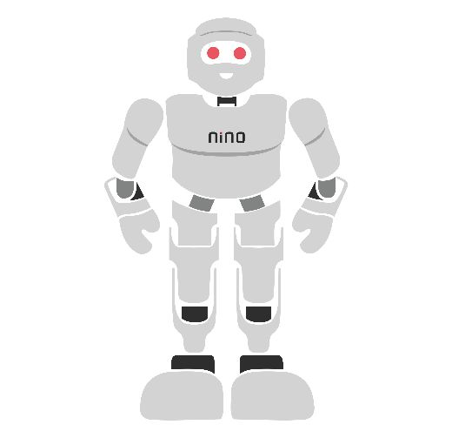

Module Overview
Wheels are fast on smooth floors, but they struggle on stairs, rubble, grass and rocks. Animals solve this problem with legs: a leg only needs a few good places to put its foot, so it can step over gaps and climb obstacles. Quadruped robots (four-legged robots) copy this idea. They are now used to inspect factories, power plants, tunnels and construction sites, and they are a favourite platform for robotics research.
This module explains how a quadruped works, in three steps. First, it introduces legged robots: their parts, how they keep their balance and why four legs are a good compromise. Second, it teaches quadruped leg kinematics: how to calculate where the foot is from the joint angles (forward kinematics) and, more importantly for walking, which joint angles put the foot where we want it (inverse kinematics). Third, it explains gaits and locomotion: the timing patterns such as crawl and trot that make the legs work together, how fast the robot moves and how it stays upright.
The module builds directly on the Semester 2 module on robot kinematics and DH parameters. All labs run in a web browser with free Python tools; an optional hardware build uses an 8-servo quadruped kit. Taught end-to-end, the module is designed to fill approximately 28–32 hours of instruction and practice.
# | Topic | Hands-on Focus
1 | Introduction to Legged Robots | Identify legs, joints and support polygons
2 | Quadruped Leg Kinematics | Lab 1: Leg forward and inverse kinematics
3 | Gaits and Locomotion | Lab 2: Gait scheduler and foot trajectories
4 | Practical Lab Exercises (with model solutions) | Lab 3: Static stability of a crawl gait
5 | Integrated Mini-Project: Walking Quadruped Simulator | Side-view walking animation (+ optional robot)
6–7 | Troubleshooting, Assessment and Revision | Formula sheet, questions, rubric

Learning Outcomes
By the end of this module, learners will be able to:
- Explain why robots use legs, and name the body, legs, joints and feet of a quadruped using standard labels (LF, RF, LH, RH).
- Describe static and dynamic stability using the centre of mass and the support polygon.
- Derive the forward kinematics of a 2-DOF quadruped leg and solve its inverse kinematics with the law of cosines.
- Calculate hip-frame foot positions from body-frame targets and extend the model to a 3-DOF leg.
- Define stance, swing, stride period, duty factor and phase, and draw gait diagrams for crawl, trot, pace and bound.
- Compute walking speed from step length, duty factor and period, and generate smooth foot trajectories.
- Evaluate the static stability margin of a crawl gait and improve it with body sway.
- Implement and troubleshoot a simple walking simulation in Python.
Hardware and Software Required
Essential items (needed by every learner):
Item | Purpose
PC or laptop with internet access | Run Python in a browser or locally
Python 3.10+ with NumPy and Matplotlib, or Google Colab | Kinematics, gait and stability calculations and plots
Graph paper, ruler, protractor, pencil | Draw legs, frames and support polygons by hand
Cardboard strips (two 10 cm links per leg) and split pins | Zero-cost model leg for checking IK by hand

Optional items (for the hardware extension and the mini-project):
Item | Purpose | Free alternative
8-DOF servo quadruped kit or frame (2 servos per leg) | Physical walking robot | Python simulation (Lab 3 and mini-project)
8 × MG90S metal-gear micro servos | Hip and knee joints | —
PCA9685 16-channel servo driver (I²C) | Drives up to 16 servos from 2 pins | —
Arduino Uno or ESP32 (from Semester 1) | Runs the gait and IK code | Wokwi simulator
6 V battery pack or 2S LiPo + 5–6 V regulator (≥ 5 A) | Servo power supply | —
PyBullet physics simulator (free, pip install pybullet) | 3D simulation of walking robots | —

Safety and equipment care
Eight servos can draw several amperes together: never power them from the microcontroller board. Join all grounds. Hold the robot in the air the first time a new gait runs, because a wrong sign can make a leg kick or bend the wrong way.
LiPo batteries must be charged only with a proper balance charger and never left charging unattended. Disconnect the battery before adjusting servo horns or legs.

1. Introduction to Legged Robots

1.1 Why Legs?
A wheel must touch the ground all the time along a continuous path. A leg touches the ground only at separate points called footholds, so it can step over a gap, climb a stair or avoid a hole. Legs also let the body stay level while the feet follow rough ground. The price is complexity: more motors, more calculation and the constant problem of not falling over.
Feature | Wheeled robot | Legged robot
Best terrain | Flat floors, roads | Stairs, rubble, grass, rocks
Ground contact | Continuous track | Separate footholds
Speed and efficiency on flat ground | High | Lower
Mechanical and control complexity | Low | High (many joints, balance)
Typical uses | Warehouses, delivery | Inspection, search and rescue, research

1.2 Types of Legged Robots
Legged robots are grouped by their number of legs. Bipeds (two legs, like humanoids) are always close to falling and need fast, careful balance control. Hexapods (six legs, like insects) can always keep three feet on the ground, so they are very stable but slow and heavy. Quadrupeds (four legs) sit in the middle: they can walk slowly with three feet down, or run with two feet down, which makes them both stable and agile. That is why most commercial legged robots today are quadrupeds.

1.3 Anatomy of a Quadruped
A quadruped has a rigid body (trunk) that carries the battery, computer and sensors, and four legs. Each leg is named by its position: LF (left front), RF (right front), LH (left hind) and RH (right hind). The body frame {B} has its origin near the centre of the body, with x pointing forward, y pointing to the robot’s left and z pointing up — a right-handed frame.
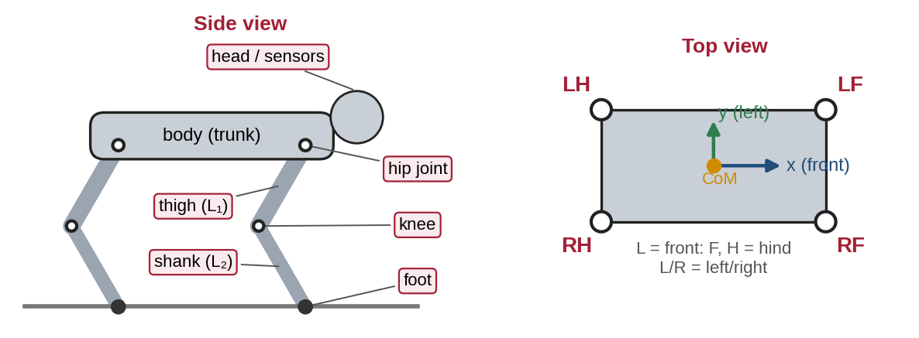
Figure 1.1: Anatomy of a quadruped robot: side view with leg parts and top view with leg names and the body frame.
Each leg is a small robot arm whose end effector is the foot. The upper part is the thigh (length L₁) and the lower part is the shank (length L₂). Most research quadrupeds have three motors per leg (Figure 1.2):
- HAA — hip abduction/adduction (roll): swings the whole leg sideways, away from or towards the body (angle θ₀).
- HFE — hip flexion/extension (pitch): swings the thigh forwards and backwards (angle θ₁).
- KFE — knee flexion/extension: bends the knee (angle θ₂).
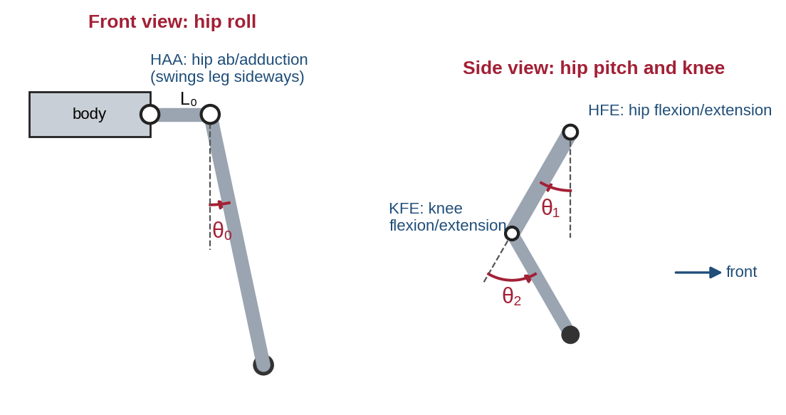
Figure 1.2: The three joints of a typical quadruped leg: hip roll (front view), hip pitch and knee (side view).
A 3-DOF leg gives 4 × 3 = 12 DOF in total. Many low-cost hobby robots remove the hip-roll joint and use 2 DOF per leg (8 DOF in total); they can walk forwards and backwards and turn by stepping, but cannot step sideways.

1.4 Real Quadruped Robots
Robot | Developer | DOF | Notes
Spot | Boston Dynamics (USA) | 12 | Commercial robot for industrial inspection
ANYmal | ANYbotics / ETH Zürich (Switzerland) | 12 | Designed for inspection in harsh industrial sites
Mini Cheetah | MIT (USA) | 12 | Small, light research robot known for dynamic moves
Go series | Unitree Robotics (China) | 12 | Lower-cost commercial and research quadrupeds
Stanford Pupper | Stanford Student Robotics (USA) | 12 | Open-source educational quadruped
Bittle | Petoi | 8 (+ head) | Small servo-based hobby and education kit

1.5 Balance: Centre of Mass and Support Polygon
The centre of mass (CoM) is the single point where the robot’s whole weight can be thought to act. Imagine drawing a line straight down from it to the floor. The support polygon is the shape you get by stretching a rubber band around all the feet that are touching the ground. A robot standing still is statically stable if the point below the CoM lies inside the support polygon (Figure 1.3). The shortest distance from that point to the edge of the polygon is the stability margin — the bigger, the safer.
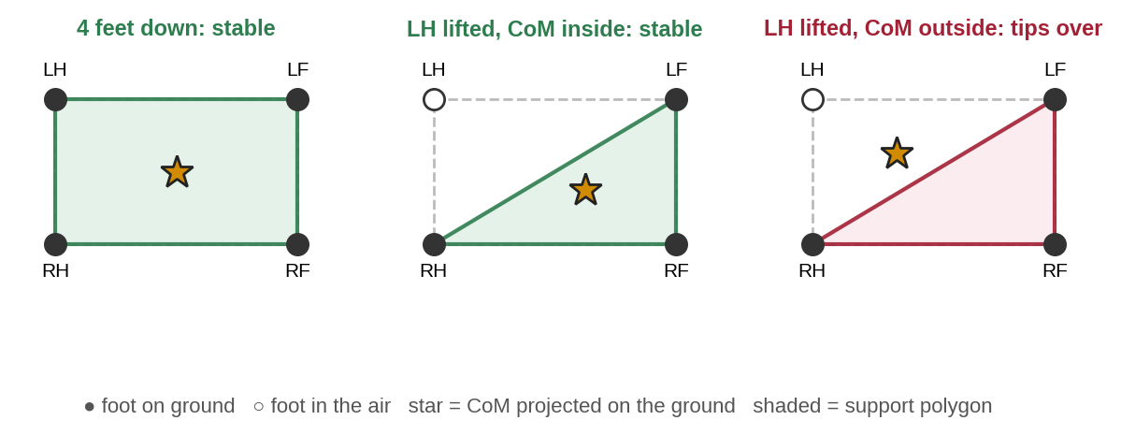
Figure 1.3: Support polygons for four and three feet on the ground; the robot tips over when the CoM projection leaves the polygon.
With three or four feet down, a robot can be statically stable, so it may stop at any moment without falling — like a slowly walking cat. With two feet down (for example during a trot), the support polygon is just a line, so the robot is only dynamically stable: it does not fall because the legs keep catching it in time, much like a person running.

1.6 Common Mistakes to Avoid
- Mixing up left and right when the robot faces you — always name legs from the robot’s own point of view.
- Counting a foot that is in the air as part of the support polygon.
- Assuming a robot that stands still will also stay up while walking — the support polygon changes with every step.

2. Quadruped Leg Kinematics

2.1 Frames and Sign Conventions
Every leg calculation in this module is done in that leg’s hip frame {H}: its origin is at the hip pitch joint, its axes are parallel to the body frame (x forward, z up), and the leg is seen from the side. We use these conventions consistently:
- θ₁ (hip pitch) is measured from the line pointing straight down; it is positive when the thigh swings forward (towards +x).
- θ₂ (knee) is measured relative to the thigh; θ₂ = 0 means the leg is straight, and θ₂ > 0 bends the knee backward (like most quadrupeds).
- L₁ = 10 cm (thigh) and L₂ = 10 cm (shank) are used in all examples; angles are in degrees on paper and radians inside code.
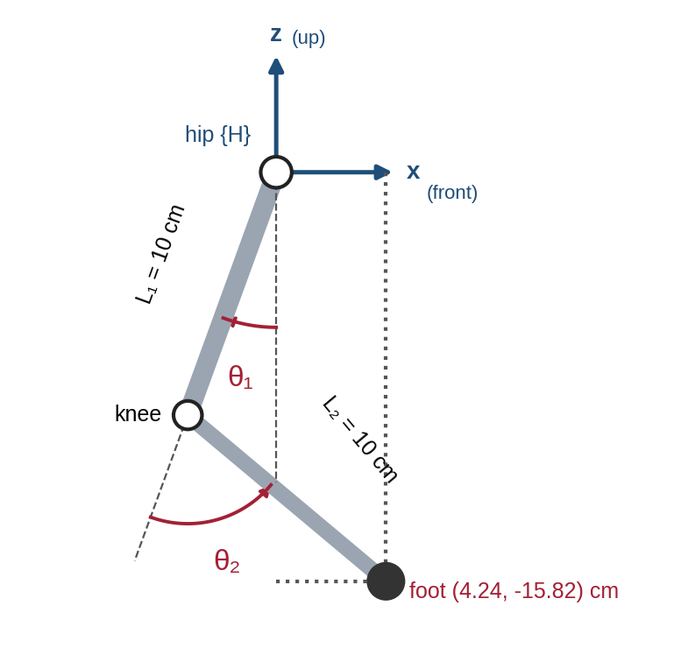
Figure 2.1: Side view of a 2-DOF quadruped leg with hip frame {H}, link lengths, joint angles and foot position (θ₁ = −20°, θ₂ = 70°).

2.2 Forward Kinematics of the Leg
Forward kinematics (FK) answers: where is the foot for given joint angles? The derivation is the same as for the 2-DOF arm of the previous module, but the leg hangs downward. Step by step:
- The thigh points at angle θ₁ from the downward vertical, so the knee is at x = L₁ sin θ₁ and z = −L₁ cos θ₁ (negative because it is below the hip).
- The shank is turned θ₂ further, so its absolute angle from the vertical is (θ₁ + θ₂).
- Add the shank’s contribution to reach the foot:
x = L₁ sin θ₁ + L₂ sin(θ₁ + θ₂)(2.1)
z = −L₁ cos θ₁ − L₂ cos(θ₁ + θ₂)(2.2)
Link to DH parameters. If frame {0} is placed at the hip with x₀ pointing down, y₀ pointing forward and z₀ along the hip axis, the leg is exactly the planar 2-link arm of the previous module, with DH rows (a = L₁, α = 0, d = 0, θ₁*) and (a = L₂, α = 0, d = 0, θ₂*). The DH result (L₁c₁ + L₂c₁₂, L₁s₁ + L₂s₁₂) gives the downward and forward distances, which are (−z, x) in equations (2.1)–(2.2).
Worked example 2.1. θ₁ = −20°, θ₂ = 70°, so θ₁ + θ₂ = 50°. x = 10 sin(−20°) + 10 sin 50° = −3.420 + 7.660 = 4.240 cm. z = −10 cos(−20°) − 10 cos 50° = −9.397 − 6.428 = −15.825 cm. The foot is 4.24 cm in front of the hip and 15.8 cm below it, matching Figure 2.1. A second useful pose is θ₁ = −30°, θ₂ = 60°: x = 0 and z = −17.32 cm, so the foot is directly below the hip — a typical standing pose.

2.3 Inverse Kinematics: From Foot Target to Joint Angles
When a robot walks, we decide where each foot should go and must find the joint angles that put it there. This is inverse kinematics (IK). For a 2-link leg it can be solved exactly with the triangle formed by the hip, the knee and the foot (Figure 2.2).
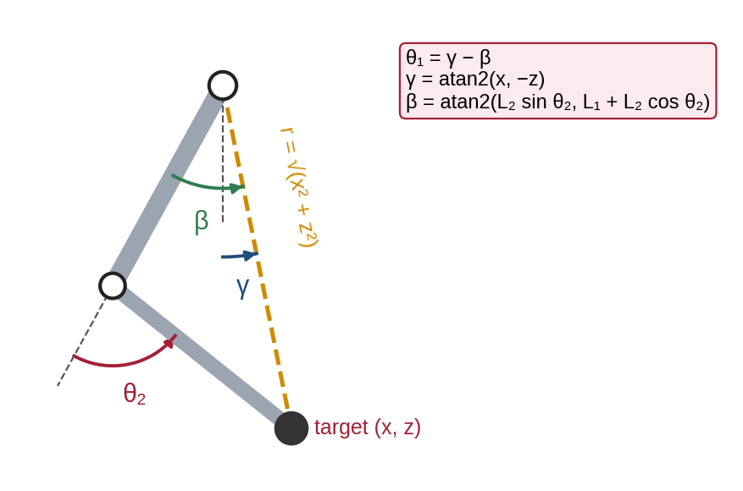
Figure 2.2: Inverse-kinematics geometry: the hip–knee–foot triangle gives the knee angle; the angles γ and β give the hip angle.
Step 1 — knee angle. The straight-line distance from hip to foot is r, with r² = x² + z². The law of cosines applied to the triangle gives:
cos θ₂ = (x² + z² − L₁² − L₂²) ÷ (2 L₁ L₂)(2.3)
If the right-hand side is greater than 1 or less than −1, the target is out of reach. Otherwise θ₂ = ± arccos(…): the positive answer gives a knee-backward leg and the negative answer a knee-forward leg (Figure 2.3).
Step 2 — hip angle. γ is the angle of the hip–foot line from the downward vertical, and β is the angle between the thigh and that line:
θ₁ = γ − β, γ = atan2(x, −z), β = atan2(L₂ sin θ₂, L₁ + L₂ cos θ₂)(2.4)
Always use atan2 (two-argument arctangent), not plain arctan: atan2 looks at the signs of both inputs and so returns the angle in the correct quadrant.
Worked example 2.2. Target foot (x, z) = (3, −15) cm. x² + z² = 9 + 225 = 234. cos θ₂ = (234 − 100 − 100) ÷ 200 = 0.170, so θ₂ = arccos 0.170 = 80.21° (knee backward). γ = atan2(3, 15) = 11.31°. β = atan2(10 sin 80.21°, 10 + 10 cos 80.21°) = atan2(9.854, 11.700) = 40.11°. θ₁ = 11.31° − 40.11° = −28.80°. Check with FK: x = 10 sin(−28.80°) + 10 sin(51.42°) = −4.817 + 7.817 = 3.000 ✓; z = −10 cos(−28.80°) − 10 cos(51.42°) = −8.763 − 6.237 = −15.000 ✓.
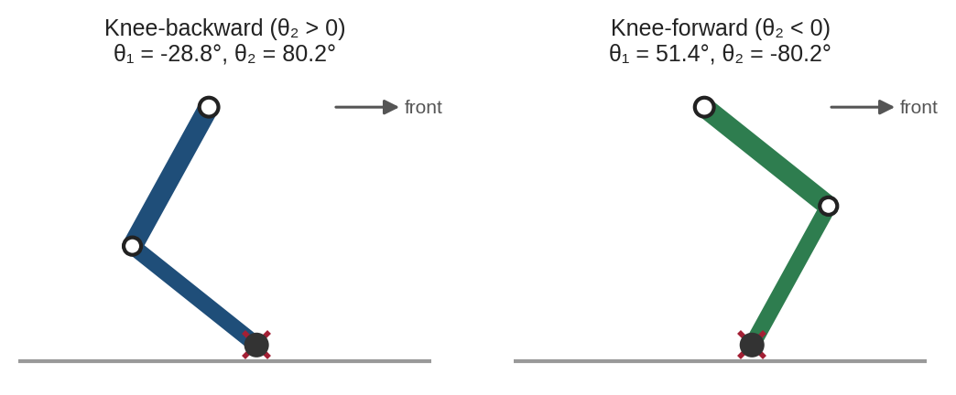
Figure 2.3: The two IK solutions for the same foot target: knee-backward and knee-forward.

2.4 Workspace, Joint Limits and Singularities
A foot can only reach points whose distance from the hip lies between |L₁ − L₂| and L₁ + L₂ (here 0 to 20 cm). Real servos and mechanical stops limit the angles further, giving the workspace of Figure 2.4. Two practical rules follow. First, never plan a fully straight leg (r = L₁ + L₂): this is a singularity, where the knee loses control of the foot’s height and tiny errors give large angle changes. Second, design the standing height (here about 15–17 cm) so that every foot target during walking stays well inside the workspace.
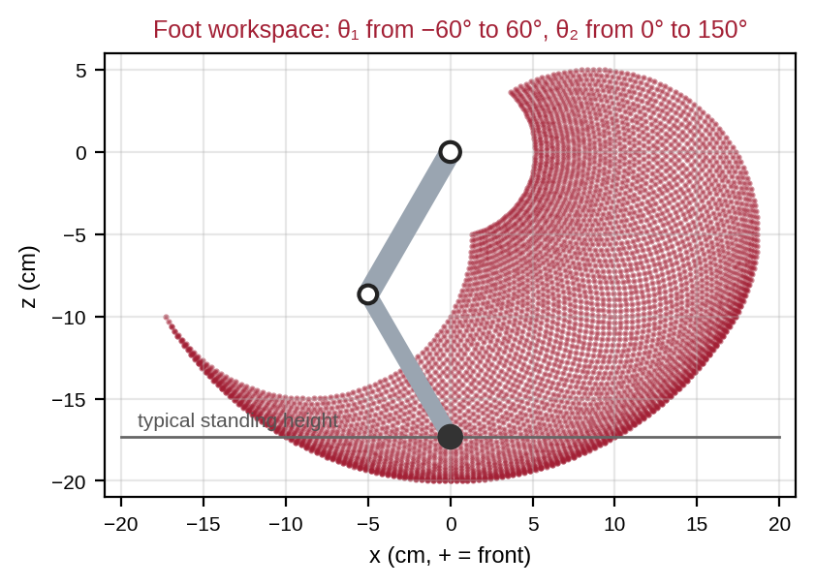
Figure 2.4: Reachable foot positions for joint limits θ₁ from −60° to 60° and θ₂ from 0° to 150°.

2.5 The 3-DOF Leg: Adding Hip Roll
A 3-DOF leg adds the hip-roll joint θ₀ in front of the 2-DOF leg. The pitch and knee joints sit at a sideways offset L₀ from the roll axis (Figure 2.5). Seen from the front, the leg plane is tilted by θ₀. If the 2-DOF part gives (x, z_p) with z_p = −(L₁ cos θ₁ + L₂ cos(θ₁ + θ₂)), the 3D foot position in the hip frame is:
x = L₁ sin θ₁ + L₂ sin(θ₁ + θ₂), y = L₀ cos θ₀ − z_p sin θ₀, z = L₀ sin θ₀ + z_p cos θ₀(2.5)
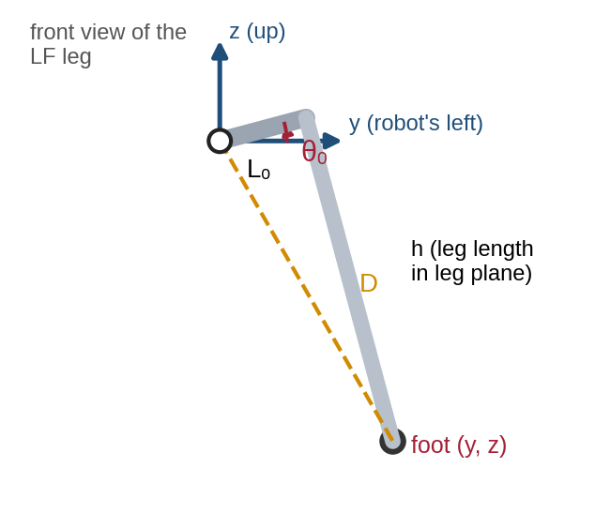
Figure 2.5: Front view of a 3-DOF leg: hip-roll angle θ₀, sideways offset L₀ and leg-plane length h.
IK in three steps: (1) in the front view, the hip-to-foot distance is D = √(y² + z²) and the leg-plane length is h = √(D² − L₀²); (2) θ₀ = atan2(z, y) + atan2(h, L₀); (3) solve the 2-DOF IK of Section 2.3 for the target (x, −h). Worked example 2.3 (L₀ = 4 cm): θ₀ = 10°, θ₁ = −20°, θ₂ = 70° gives z_p = −15.825 and, from (2.5), foot = (4.240, 6.687, −14.890) cm. Running the three IK steps on this point returns exactly θ₀ = 10°, θ₁ = −20°, θ₂ = 70° — a round-trip check that you will repeat in Lab 1.

2.6 From the Body Frame to Each Hip
Walking commands are given for the whole body ("move forward 5 cm"), but IK works per leg. Because each hip frame is parallel to the body frame and only shifted, converting a foot target is a simple subtraction:
p_foot,hip = p_foot,body − p_hip,body(2.6)
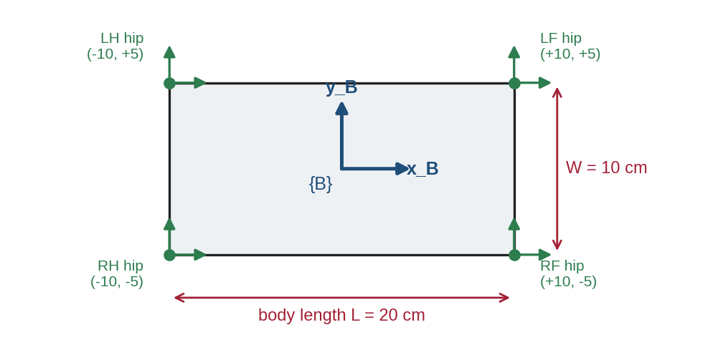
Figure 2.6: Body frame {B} and the four hip positions for a body 20 cm long and 10 cm wide.
Worked example 2.4. The LF hip is at (10, 5, 0) cm in {B}. The planner wants the LF foot at (13, 5, −15) cm in {B}. In the hip frame the target is (13 − 10, 5 − 5, −15 − 0) = (3, 0, −15) — exactly the target of Worked example 2.2, so θ₁ = −28.80° and θ₂ = 80.21°. Lowering the whole body by 2 cm is just as easy: every foot target’s z changes from −15 to −13. If the body is also tilted, the targets must first be rotated with the rotation matrices of the previous module before subtracting the hip offsets.

2.7 Common Mistakes to Avoid
- Measuring θ₁ from the horizontal instead of from the downward vertical — every result is shifted by 90°.
- Forgetting the minus sign in z: feet are below the hip, so z is negative.
- Using arctan(x / z) instead of atan2(x, −z), which gives wrong answers when x or z changes sign.

3. Gaits and Locomotion

3.1 Stance, Swing and the Stride Cycle
Walking is a repeating cycle. During stance, a foot is on the ground and pushes the body forward; relative to the body it moves backward. During swing, the foot is lifted and carried forward to its next foothold. One complete stance-plus-swing cycle takes the stride period T (seconds). The fraction of the cycle a foot spends on the ground is the duty factor β:
β = stance time ÷ T, stance time = β·T, swing time = (1 − β)·T(3.1)
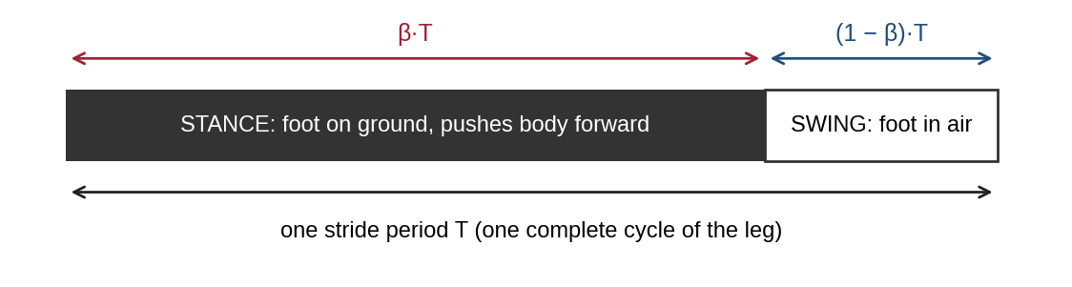
Figure 3.1: One stride cycle of a single leg divided into stance (β·T) and swing ((1 − β)·T).
A gait is the pattern that tells each leg when to start its stance. We describe it with a phase offset for each leg: the moment the foot touches down, as a fraction of T (0 to 1). If β > 0.5, each leg spends more time on the ground than in the air; this is typical of slow, careful gaits.

3.2 Gait Diagrams and the Main Quadruped Gaits
A gait diagram draws one horizontal line per leg against time; a black bar means the foot is on the ground. Reading down a vertical line shows which feet are supporting the robot at that instant (Figure 3.2).
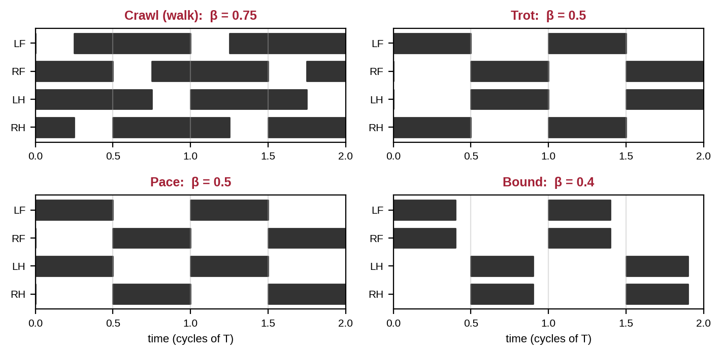
Figure 3.2: Gait diagrams (black = stance) for crawl, trot, pace and bound over two cycles.
Gait | Phase offsets (LF, RF, LH, RH) | Typical β | Feet on ground | Stability | Notes
Crawl (walk) | 0.25, 0.75, 0, 0.5 | ≥ 0.75 | 3 or 4 | Static | Slowest, safest; one leg lifts at a time (LH → LF → RH → RF)
Trot | 0, 0.5, 0.5, 0 | ≈ 0.5 | 2 (diagonal) | Dynamic | Diagonal pairs move together; the most common robot gait
Pace | 0, 0.5, 0, 0.5 | ≈ 0.5 | 2 (same side) | Dynamic | Body rocks side to side; used by camels and some dogs
Bound | 0, 0, 0.5, 0.5 | < 0.5 | 0–2 (front or back) | Dynamic | Front pair then hind pair; body pitches up and down
Gallop | Four different offsets | < 0.5 | 0–2 | Dynamic | Fastest gait of animals; has flight phases
Pronk | All equal | < 0.5 | 0 or 4 | Dynamic | All four legs together, like a jump

3.3 Speed, Step Length and Stride Length
During stance, a foot moves backward relative to the body by the step length S, and it does so in the stance time βT. Because the foot is fixed to the ground, the body must move forward by S in that same time. The body’s speed is therefore:
v = S ÷ (β·T), stride length (distance per cycle) = v·T = S ÷ β(3.2)
Worked example 3.1 (crawl). S = 6 cm, T = 2.0 s, β = 0.75: v = 6 ÷ (0.75 × 2.0) = 4.0 cm/s; the body travels 8 cm per cycle and each swing lasts (1 − 0.75) × 2.0 = 0.5 s. Worked example 3.2 (trot). S = 6 cm, T = 0.8 s, β = 0.5: v = 6 ÷ 0.4 = 15 cm/s, stride length 12 cm, swing time 0.4 s. The same legs move almost four times faster in a trot because more time is spent pushing and less waiting.
To walk faster you can increase S (limited by the workspace), shorten T (limited by how fast the servos can swing the leg) or lower β (which means fewer feet on the ground and the need for dynamic balance).

3.4 Designing Foot Trajectories
The path a foot follows relative to the hip during one cycle is its foot trajectory (Figure 3.3). In stance, the foot moves backward in a straight line at constant height z = −h (h = standing height), so the body moves smoothly and level. In swing, it must lift by a step height H to clear obstacles and land gently. A simple, smooth choice is the cycloid, with swing progress s going from 0 to 1:
x = −S/2 + S·(s − sin(2πs) ÷ 2π), z = −h + H·(1 − cos 2πs) ÷ 2(3.3)
Both the speed and the height of the foot are zero at the start and end of the swing, so the foot lifts off and touches down without slipping or stamping. In stance, x goes from +S/2 to −S/2 linearly in time. Each trajectory point is then converted to joint angles with the IK of Section 2.3 — tens of times per second.
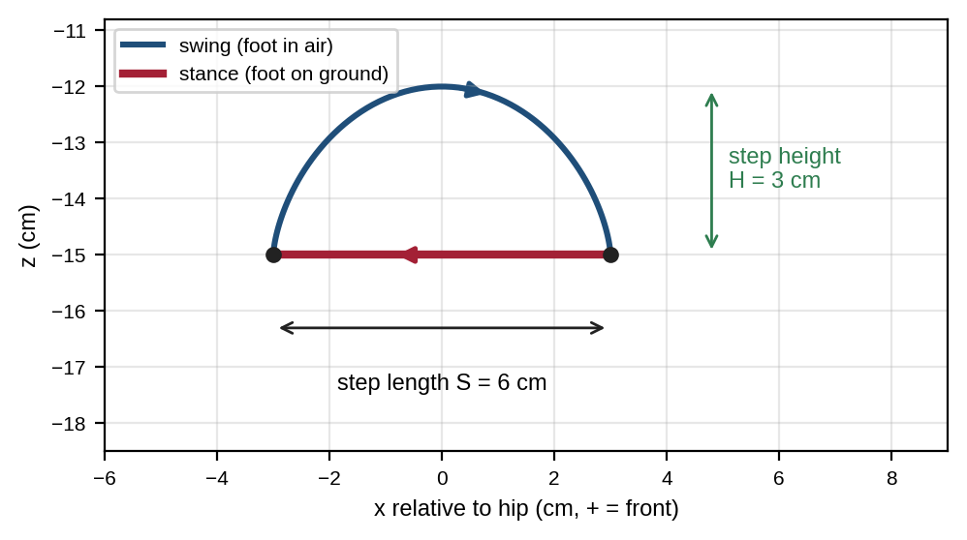
Figure 3.3: Foot trajectory relative to the hip: straight-line stance and cycloid swing (S = 6 cm, H = 3 cm, h = 15 cm).

3.5 Static Stability and the Crawl Gait
In a crawl, one leg is in the air at a time, so the support polygon alternates between a quadrilateral (four feet) and a triangle (three feet). The robot stays statically stable only if the CoM stays inside the triangle while each leg swings. The stability margin is the shortest distance from the CoM projection to any edge; for an edge from (x₁, y₁) to (x₂, y₂) and a CoM at (x₀, y₀):
d = [(x₂ − x₁)(y₀ − y₁) − (y₂ − y₁)(x₀ − x₁)] ÷ √((x₂ − x₁)² + (y₂ − y₁)²)(3.4)
With the polygon corners listed anticlockwise, d is positive when the CoM is inside that edge. The margin is the smallest d over all edges; a negative margin means the robot tips over.
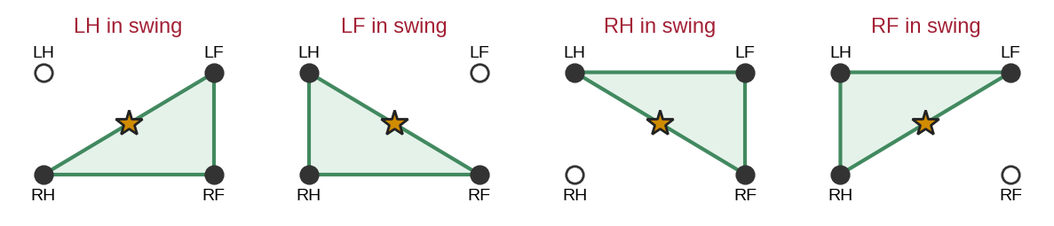
Figure 3.4: Support triangles during a crawl cycle; with the CoM at the body centre it lies on a diagonal edge, so the margin is zero.
Figure 3.4 shows a famous problem: for a symmetric robot, the CoM sits exactly on the diagonal between the two opposite feet that remain down. The margin is zero and any disturbance tips the robot. Real crawling robots and animals fix this with body sway: just before a leg lifts, the body shifts towards the centre of the triangle that will support it. In Lab 3 you will measure how much margin this gains.

3.6 Dynamic Gaits, Froude Number and Gait Control
In a trot only two diagonal feet support the robot, so it cannot stop in mid-step without falling — it is balanced by the regular timing of the legs, like a person running. Faster robots also use force sensors, an inertial measurement unit (IMU) and controllers that adjust where each foot lands. Advanced methods use ideas such as the zero-moment point (ZMP) and model predictive control; these are beyond this module.
A useful way to compare walking speeds across sizes is the dimensionless Froude number, Fr = v² ÷ (g·h), where g = 9.81 m/s² and h is leg length in metres. Alexander and Jayes found that mammals of very different sizes tend to change gait at similar Froude numbers — roughly 0.5 for walk to trot and 2–3 for trot to gallop. A hobby robot trotting at 0.15 m/s with h = 0.17 m has Fr ≈ 0.013, far below these values, which is why simple timed gaits work well for it.
Many robots generate gait timing with a central pattern generator (CPG): a set of coupled oscillators, inspired by neural circuits in animal spinal cords, that produce rhythmic phases for each leg. The simple phase-offset scheduler used in this module is the most basic form of this idea.

3.7 Putting It Together: The Locomotion Pipeline
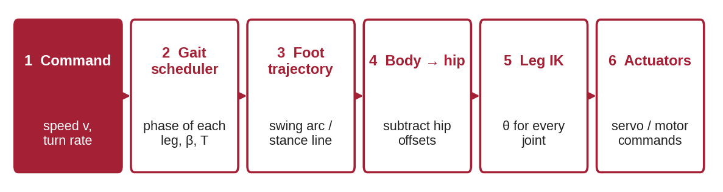
Figure 3.5: Locomotion pipeline from a speed command to joint commands, repeated every control cycle.
Every control cycle (typically 50–500 times per second) the robot: reads the desired speed; uses the gait scheduler to find each leg’s phase; computes each foot target on its trajectory; converts the targets from the body frame to each hip frame; runs IK for every leg; and sends the angles to the motors. Turning is achieved by giving the left and right legs different step lengths, or by rotating every foot target slightly about the body’s vertical axis.

3.8 Common Mistakes to Avoid
- Defining phase offsets as lift-off times in one place and touchdown times in another.
- Choosing β < 0.75 for a crawl and expecting it to be statically stable.
- Using a step length that pushes feet outside the leg workspace at the ends of the stance.
- Forgetting that the stance foot moves backward relative to the body while the body moves forward.

4. Practical Lab Exercises
The three labs turn Sections 2 and 3 into working tools that later combine into the mini-project. All of them run in a web browser with Google Colab (free; NumPy and Matplotlib are pre-installed) or on any computer with Python. Each lab gives its time, prerequisites, exact steps and the evidence to record, and ends with a model solution.
Lab | Title | Section | Time | Hardware
1 | Leg forward and inverse kinematics | 2 | 2.5 h | None (cardboard leg optional)
2 | Gait scheduler and foot-trajectory generator | 3.1–3.4 | 2.5 h | None
3 | Static stability of a crawl gait with body sway | 3.5 | 2.5 h | None

Software Setup (once, before Lab 1)
- No installation: open colab.research.google.com, choose File → New notebook, paste a program into a cell and press Shift + Enter.
- Own computer: install Python 3.10+ from python.org, then run pip install numpy matplotlib and start a program with python filename.py.
- Check the setup with import numpy, matplotlib; print(numpy.__version__).

Lab Exercise 1: Leg Forward and Inverse Kinematics
Estimated time | Prerequisites
2.5 hours | Sections 2.1–2.5; basic Python functions; setup completed

Objective
To implement forward and inverse kinematics for one 2-DOF quadruped leg, verify IK by feeding its answers back into FK, detect unreachable targets and plot the leg in several poses.
Components Required
- PC or laptop; graph paper, ruler and protractor
- Optional: cardboard leg with two 10 cm links and split pins
Software Required
- Python 3.10+ with NumPy and Matplotlib, or Google Colab
Working Principle
fk() implements equations (2.1)–(2.2). ik() implements (2.3)–(2.4): it computes cos θ₂, raises a ValueError if the target is out of reach, picks the knee-backward solution and finds θ₁ with atan2. A round-trip test — target → IK → FK → target — proves both functions are consistent.
Model Setup
Draw the hip frame on graph paper with the hip at the top centre. Mark the targets (0, −17.32), (3, −15), (−4, −16) and (6, −12). If you made the cardboard leg, pin the hip at the origin and check each IK answer with the protractor.
Procedure
- Calculate by hand the FK of (θ₁, θ₂) = (−30°, 60°) and the IK of (3, −15). Write the results down.
- Enter and run the program below. Copy the FK and IK tables into the observation table.
- Compare the program’s results with your hand calculations.
- Change the call to ik(x, z, knee_back=False) for the target (3, −15) and record the knee-forward angles.
- Note what happens with the target (0, −21) and explain why.
- Extension: add the 3-DOF functions of Section 2.5 (L₀ = 4 cm) and perform a round-trip test with θ₀ = 10°, θ₁ = −20°, θ₂ = 70°.
Program Code
# Lab 1: forward and inverse kinematics of one quadruped leg (side view)
import numpy as np
import matplotlib.pyplot as plt

L1, L2 = 10.0, 10.0 # thigh and shank length (cm)

def fk(t1_deg, t2_deg):
"""Foot (x, z) in the hip frame. theta1 from the downward vertical, + = front."""
a, b = np.radians(t1_deg), np.radians(t2_deg)
x = L1*np.sin(a) + L2*np.sin(a + b)
z = -L1*np.cos(a) - L2*np.cos(a + b)
return x, z

def ik(x, z, knee_back=True):
"""Joint angles (deg) that put the foot at (x, z). Raises ValueError if unreachable."""
c2 = (x*x + z*z - L1**2 - L2**2) / (2*L1*L2)
if abs(c2) > 1:
raise ValueError(f"target ({x}, {z}) is out of reach")
t2 = np.arccos(c2) if knee_back else -np.arccos(c2)
t1 = np.arctan2(x, -z) - np.arctan2(L2*np.sin(t2), L1 + L2*np.cos(t2))
return np.degrees(t1), np.degrees(t2)

print("FK tests")
for t1, t2 in [(0, 0), (-30, 60), (-20, 70), (10, 40)]:
x, z = fk(t1, t2)
print(f" theta1={t1:5.1f} theta2={t2:5.1f} -> x={x:7.3f} z={z:8.3f}")

print("IK tests (with FK round-trip check)")
targets = [(0, -17.32), (3, -15), (-4, -16), (6, -12), (0, -21)]
for x, z in targets:
try:
t1, t2 = ik(x, z)
xc, zc = fk(t1, t2)
print(f" ({x:5.1f}, {z:6.2f}) -> theta1={t1:7.2f} theta2={t2:7.2f} "
f"check ({xc:5.2f}, {zc:6.2f})")
except ValueError as e:
print(" ", e)

# Plot the leg for several reachable targets
plt.figure(figsize=(5, 5))
for x, z in targets[:4]:
t1, t2 = ik(x, z)
a = np.radians(t1)
kx, kz = L1*np.sin(a), -L1*np.cos(a)
plt.plot([0, kx, x], [0, kz, z], "-o", lw=3, label=f"foot ({x}, {z})")
plt.axhline(-17.32, color="grey", lw=0.8, ls="--")
plt.gca().set_aspect("equal"); plt.grid(alpha=0.3); plt.legend(fontsize=8)
plt.xlabel("x (cm, + = front)"); plt.ylabel("z (cm)"); plt.title("IK solutions, knee backward")
plt.savefig("lab1_output.png", dpi=150, bbox_inches="tight"); plt.show()

Expected Output
FK tests
theta1= 0.0 theta2= 0.0 -> x= 0.000 z= -20.000
theta1=-30.0 theta2= 60.0 -> x= 0.000 z= -17.321
theta1=-20.0 theta2= 70.0 -> x= 4.240 z= -15.825
theta1= 10.0 theta2= 40.0 -> x= 9.397 z= -16.276
IK tests (with FK round-trip check)
( 0.0, -17.32) -> theta1= -30.00 theta2= 60.01 check ( 0.00, -17.32)
( 3.0, -15.00) -> theta1= -28.80 theta2= 80.21 check ( 3.00, -15.00)
( -4.0, -16.00) -> theta1= -48.49 theta2= 68.90 check (-4.00, -16.00)
( 6.0, -12.00) -> theta1= -21.30 theta2= 95.74 check ( 6.00, -12.00)
target (0, -21) is out of reach

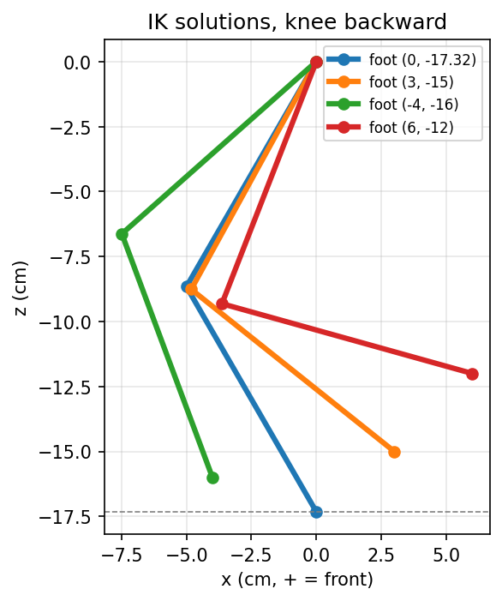
Figure 4.1: Output of Lab 1: knee-backward IK solutions for four foot targets.
Observation
Record your results and attach a screenshot of the output and plot.
# | What to observe | Your observation
1 | Hand FK of (−30°, 60°) and program result
2 | Hand IK of (3, −15) and program result
3 | Knee-forward angles for (3, −15)
4 | Message for target (0, −21) and the reason
5 | 3-DOF round-trip result (extension)

Model Solution
# | Correct result | Explanation
1 | (0.000, −17.321) cm | sin(−30°) + sin(30°) = 0; −cos 30° − cos 30° = −1.732
2 | θ₁ = −28.80°, θ₂ = 80.21° | Worked example 2.2; FK returns (3.00, −15.00)
3 | θ₁ = 51.42°, θ₂ = −80.21° | Same foot, knee pointing forward (Figure 2.3)
4 | "out of reach" | r = 21 cm > L₁ + L₂ = 20 cm, so |cos θ₂| > 1
5 | Foot (4.240, 6.687, −14.890) cm → IK returns (10°, −20°, 70°) | fk3/ik3 of Section 2.5 are consistent

Extension code (model answer):
L0 = 4.0
def fk3(t0, t1, t2):
x, zp = fk(t1, t2)
c, s = np.cos(np.radians(t0)), np.sin(np.radians(t0))
return x, L0*c - zp*s, L0*s + zp*c
def ik3(x, y, z):
h = np.sqrt(y*y + z*z - L0**2)
t0 = np.degrees(np.arctan2(z, y) + np.arctan2(h, L0))
t1, t2 = ik(x, -h)
return t0, t1, t2
print(ik3(*fk3(10, -20, 70))) # -> approximately (10.0, -20.0, 70.0)

Precautions
- Convert degrees to radians before np.sin / np.cos; convert back with np.degrees for display.
- Keep L₁ and L₂ in the same unit as the targets.
Applications
This IK runs inside every walking robot many times per second, once per leg. The same round-trip test is how engineers check a new robot model before connecting real motors.
Conclusion
FK and IK of a 2-link leg are exact and fast; IK has two solutions and must reject unreachable targets. Evidence to record: hand calculations, program output, plot and completed tables.

Lab Exercise 2: Gait Scheduler and Foot-Trajectory Generator
Estimated time | Prerequisites
2.5 hours | Sections 3.1–3.4; Lab 1 completed

Objective
To build a gait scheduler that computes each leg’s phase from its offset, generate stance-line and cycloid-swing foot trajectories, draw gait diagrams for crawl and trot, and verify the speed formula v = S ÷ (βT).
Components Required
- PC or laptop (no hardware)
Software Required
- Python 3.10+ with NumPy and Matplotlib, or Google Colab
Working Principle
For each leg the phase is φ = (t/T − offset) mod 1. If φ < β the leg is in stance and its foot moves from +S/2 to −S/2; otherwise it is in swing and follows the cycloid of equation (3.3). The program prints the stance and swing times, the speed, the stride length and the smallest number of feet that are ever on the ground, then draws a gait diagram and the LF foot’s x and z against time.
Procedure
- By hand, compute v, stride length and swing time for the crawl (S = 6 cm, T = 2 s, β = 0.75) and the trot (T = 0.8 s, β = 0.5).
- Run the program below and compare its printed values and plots with your answers and with Figure 3.2.
- Add a pace gait to GAITS and simulate it with T = 0.8 s.
- Change the crawl duty factor to β = 0.6. Record the minimum number of feet on the ground and explain the result.
- Change the trot period to T = 0.6 s and the crawl step length to S = 8 cm. Record the new speeds.
Program Code
# Lab 2: gait scheduler + foot trajectory generator for a quadruped
import numpy as np
import matplotlib.pyplot as plt

GAITS = { # touchdown time of each leg as a fraction of the cycle, and duty factor
"crawl": ({"LF": 0.25, "RF": 0.75, "LH": 0.0, "RH": 0.5}, 0.75),
"trot": ({"LF": 0.0, "RF": 0.5, "LH": 0.5, "RH": 0.0}, 0.5),
}
S, H, h = 6.0, 3.0, 15.0 # step length, step height, standing height (cm)

def foot(phase, beta):
"""Foot (x, z) in the hip frame for a leg phase 0..1. Returns (x, z, in_stance)."""
if phase < beta: # stance: straight line backwards
return S/2 - S*phase/beta, -h, True
s = (phase - beta) / (1 - beta) # swing progress 0..1
x = -S/2 + S*(s - np.sin(2*np.pi*s)/(2*np.pi)) # cycloid: zero speed at both ends
z = -h + H*(1 - np.cos(2*np.pi*s))/2
return x, z, False

def simulate(name, T, n=400):
offsets, beta = GAITS[name]
t = np.linspace(0, 2*T, n)
data = {}
for leg, off in offsets.items():
ph = (t/T - off) % 1.0
data[leg] = np.array([foot(p, beta) for p in ph])
v = S / (beta*T)
print(f"{name:5s}: T={T} s, beta={beta}, stance={beta*T:.2f} s, swing={(1-beta)*T:.2f} s, "
f"speed={v:.1f} cm/s, stride={v*T:.1f} cm, min legs on ground="
f"{int(min(sum(data[l][i, 2] for l in data) for i in range(n)))}")
return t, data

fig, axs = plt.subplots(2, 2, figsize=(10, 6))
for col, (name, T) in enumerate([("crawl", 2.0), ("trot", 0.8)]):
t, data = simulate(name, T)
for i, leg in enumerate(["LF", "RF", "LH", "RH"]):
axs[0, col].fill_between(t, 3-i-0.35, 3-i+0.35, where=data[leg][:, 2] > 0.5, color="k", step="mid")
axs[0, col].set_yticks([3, 2, 1, 0]); axs[0, col].set_yticklabels(["LF", "RF", "LH", "RH"])
axs[0, col].set_title(f"{name} gait diagram (black = stance)")
axs[1, col].plot(t, data["LF"][:, 0], label="LF x (cm)")
axs[1, col].plot(t, data["LF"][:, 1] + h, label="LF z + h (cm)")
axs[1, col].set_xlabel("time (s)"); axs[1, col].legend(fontsize=8); axs[1, col].grid(alpha=0.3)
plt.tight_layout(); plt.savefig("lab2_output.png", dpi=150); plt.show()

Expected Output
crawl: T=2.0 s, beta=0.75, stance=1.50 s, swing=0.50 s, speed=4.0 cm/s, stride=8.0 cm, min legs on ground=3
trot : T=0.8 s, beta=0.5, stance=0.40 s, swing=0.40 s, speed=15.0 cm/s, stride=12.0 cm, min legs on ground=2

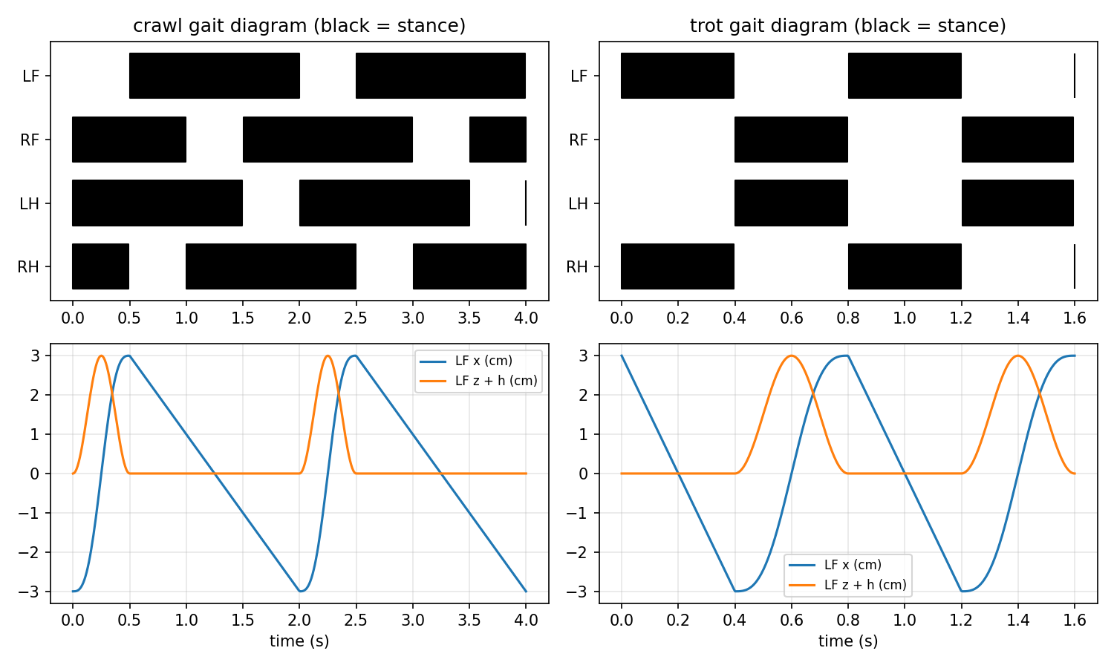
Figure 4.2: Output of Lab 2: gait diagrams (top) and LF foot trajectory against time (bottom) for crawl and trot.
Observation
# | What to observe | Your observation
1 | Speed, stride and swing time: crawl and trot
2 | Gait diagram matches Figure 3.2? (yes / no, differences)
3 | Pace output line
4 | Crawl with β = 0.6: minimum feet on ground
5 | Speeds for trot T = 0.6 s and crawl S = 8 cm

Model Solution
# | Correct result | Explanation
1 | Crawl 4.0 cm/s, 8.0 cm, 0.50 s; trot 15.0 cm/s, 12.0 cm, 0.40 s | Worked examples 3.1 and 3.2
2 | Yes | Crawl lifts LH, LF, RH, RF in turn; trot moves diagonal pairs
3 | Pace: same numbers as trot (15.0 cm/s), min 2 feet | Speed depends on S, β and T, not on which legs pair up
4 | 2 feet | Swing (0.4 T) is longer than the 0.25 T gap between legs, so two legs are sometimes in the air: no longer statically stable
5 | Trot 20.0 cm/s; crawl 5.3 cm/s (stride 10.7 cm) | 6 ÷ (0.5 × 0.6) = 20; 8 ÷ (0.75 × 2) = 5.33

Precautions
- Use one phase convention (touchdown time) everywhere.
- Keep S small enough that every point of the trajectory is inside the leg workspace — test it with ik() from Lab 1.
Applications
Gait schedulers of this kind drive hobby robots such as Stanford Pupper and form the timing layer of more advanced controllers on research robots.
Conclusion
Phase offsets and the duty factor fully define a gait; speed follows from v = S ÷ (βT); and β ≥ 0.75 is needed for a crawl to keep three feet on the ground. Evidence to record: hand calculations, printed lines, plots and the completed tables.

Lab Exercise 3: Static Stability of a Crawl Gait with Body Sway
Estimated time | Prerequisites
2.5 hours | Sections 1.5 and 3.5; Lab 2 completed

Objective
To compute the support polygon and the static stability margin of a crawling quadruped over one full cycle, show that a symmetric robot without body sway has zero margin, and measure how body sway improves it.
Components Required
- PC or laptop; graph paper for sketching support triangles
Software Required
- Python 3.10+ with NumPy and Matplotlib, or Google Colab
Working Principle
The program places the four feet in the top view at (±10, ±7) cm and moves them with the crawl gait (T = 4 s, β = 0.75, S = 6 cm). At every instant it lists the stance feet in anticlockwise order and applies equation (3.4) to every edge; the smallest distance is the margin. With sway, the CoM is moved towards the centre of the triangle that supports the robot during the current or next swing; the sway factor (0 to 1) sets how far.
Procedure
- Sketch the four support triangles of Figure 3.4 on graph paper and mark the CoM at (0, 0). Measure the margin by hand.
- Run the program below and record the minimum margin and the time spent with margin below 1 cm, for sway factors 0 and 0.5.
- Run again with sway factors 0.3 and 0.8 and record the minimum margins.
- Change the nominal foot positions to (±10, ±9) cm (wider stance) and repeat for sway 0 and 0.5.
Program Code
# Lab 3: static stability margin of a crawl gait, with and without body sway (top view)
import numpy as np
import matplotlib.pyplot as plt

T, beta, S = 4.0, 0.75, 6.0
OFFSETS = {"LF": 0.25, "RF": 0.75, "LH": 0.0, "RH": 0.5} # crawl: LH, LF, RH, RF
HIP = {"LF": (10, 7), "RF": (10, -7), "LH": (-10, 7), "RH": (-10, -7)} # nominal feet (cm)
ORDER = ["LF", "LH", "RH", "RF"] # counter-clockwise order

def foot_x(phase):
if phase < beta:
return S/2 - S*phase/beta # stance: moves backwards
s = (phase - beta)/(1 - beta)
return -S/2 + S*s # swing: returns forwards

def margin(com, pts):
"""Signed distance from com to the nearest edge of a convex CCW polygon (cm)."""
d = []
for i in range(len(pts)):
(x1, y1), (x2, y2) = pts[i], pts[(i+1) % len(pts)]
ex, ey = x2-x1, y2-y1
d.append((ex*(com[1]-y1) - ey*(com[0]-x1)) / np.hypot(ex, ey)) # + = inside
return min(d)

def run(sway, n=800):
t = np.linspace(0, T, n, endpoint=False); m = []
for ti in t:
feet, support, nxt = {}, [], None
for leg in ORDER:
ph = (ti/T - OFFSETS[leg]) % 1.0
feet[leg] = (HIP[leg][0] + foot_x(ph), HIP[leg][1])
if ph < beta: support.append(leg)
# leg to avoid: the one in swing, or (all four down) the next one to lift
if len(support) == 3:
out = [l for l in ORDER if l not in support][0]
else:
out = max(support, key=lambda l: (ti/T - OFFSETS[l]) % 1.0)
tri = [feet[l] for l in ORDER if l != out]
com = np.mean(tri, axis=0)*sway if sway else np.zeros(2)
m.append(margin(com, [feet[l] for l in ORDER if l in support]))
return t, np.array(m)

for sway in [0.0, 0.5]:
t, m = run(sway)
print(f"sway factor {sway}: minimum stability margin = {m.min():6.2f} cm, "
f"time with margin < 1 cm = {100*np.mean(m < 1):5.1f} %")
plt.plot(t, m, label=f"sway factor {sway}")
plt.axhline(0, color="r", lw=1); plt.xlabel("time (s)"); plt.ylabel("stability margin (cm)")
plt.title("Crawl gait: CoM distance to support-polygon edge"); plt.grid(alpha=0.3); plt.legend()
plt.savefig("lab3_output.png", dpi=150, bbox_inches="tight"); plt.show()

Expected Output
sway factor 0.0: minimum stability margin = 0.00 cm, time with margin < 1 cm = 81.2 %
sway factor 0.5: minimum stability margin = 2.25 cm, time with margin < 1 cm = 0.0 %

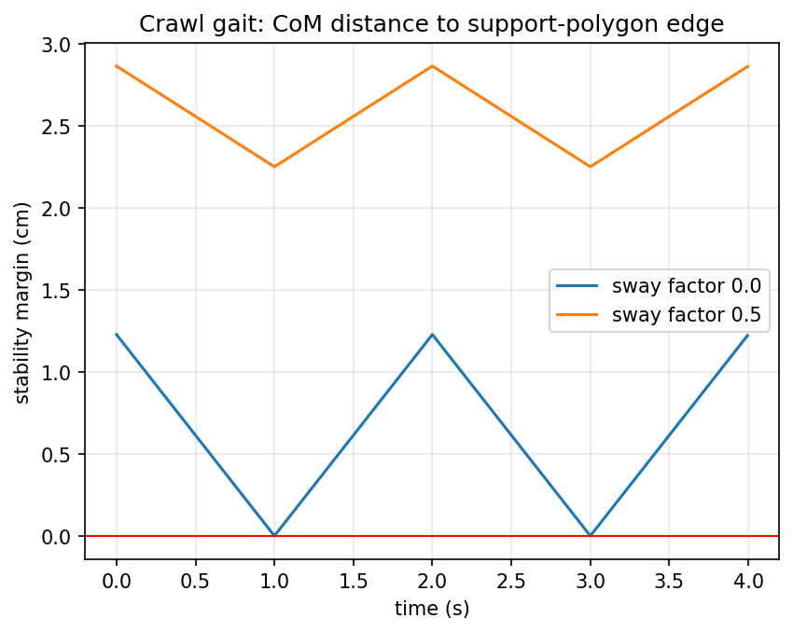
Figure 4.3: Output of Lab 3: stability margin over one crawl cycle without sway and with sway factor 0.5.
Observation
# | What to observe | Your observation
1 | Hand-measured margin with CoM at (0, 0)
2 | Minimum margin and time below 1 cm: sway 0 and 0.5
3 | Minimum margin: sway 0.3 and 0.8
4 | Wide stance (±9 cm): minimum margin for sway 0 and 0.5

Model Solution
# | Correct result | Explanation
1 | 0 cm | The CoM lies on the diagonal edge between opposite stance feet
2 | Sway 0: 0.00 cm, 81.2 %; sway 0.5: 2.25 cm, 0.0 % | Sway moves the CoM into the support triangle
3 | Sway 0.3: 1.35 cm; sway 0.8: 3.60 cm | More sway gives more margin, but larger body motion
4 | Sway 0: 0.00 cm; sway 0.5: 2.59 cm | A wider stance helps only when the body also sways

Precautions
- List polygon corners anticlockwise (otherwise every margin changes sign), and treat a margin close to zero as unsafe.
Conclusion
A crawl gait keeps three feet down, but stability also needs the CoM inside the support triangle; body sway turns a zero-margin gait into a safe one. Evidence to record: sketches, printed results, plot and completed tables.

5. Integrated Mini-Project: Walking Quadruped Simulator

5.1 Problem Statement and System Design
Build a side-view simulator that shows a quadruped trotting forward. It must use the gait scheduler and trajectories of Lab 2 to create foot targets, the IK of Lab 1 to turn them into joint angles, and it must stop with an error if any target is unreachable. An optional extension runs the same algorithm on an 8-servo robot.
Block | Function | Built in
Gait scheduler | Trot phases, T = 0.8 s, β = 0.5 | Lab 2
Foot trajectory | Stance line and cycloid swing, S = 6 cm, H = 3 cm, h = 15 cm | Lab 2
Leg IK | Knee-backward solution with reachability check | Lab 1
Display | Body, four legs (far legs faded), joint angles, moving camera | This project
Optional hardware | PCA9685 driver + 8 servos running the same maths | This project

5.2 Workflow and Code
(1) Copy foot() from Lab 2 and ik() from Lab 1. (2) Write pose(t) that returns hip, knee and foot points for every leg; the body moves forward at v = S ÷ (βT). (3) Write draw(ax, t). (4) Save four snapshots and run the animation with python miniproject_walker.py on your own computer (animations in Colab need extra set-up).
# Mini-project: side-view walking quadruped = gait generator (Lab 2) + leg IK (Lab 1)
import numpy as np
import matplotlib.pyplot as plt
from matplotlib.animation import FuncAnimation

L1, L2 = 10.0, 10.0
S, H, h = 6.0, 3.0, 15.0 # step length, step height, standing height (cm)
GAIT = ({"LF": 0.0, "RF": 0.5, "LH": 0.5, "RH": 0.0}, 0.5) # trot
T, BODY = 0.8, 20.0 # period (s), hip-to-hip length (cm)
HIP_X = {"LF": BODY/2, "RF": BODY/2, "LH": -BODY/2, "RH": -BODY/2}

def ik(x, z):
c2 = (x*x + z*z - L1**2 - L2**2) / (2*L1*L2)
assert abs(c2) <= 1, "foot target out of reach"
t2 = np.arccos(c2) # knee backward
t1 = np.arctan2(x, -z) - np.arctan2(L2*np.sin(t2), L1 + L2*np.cos(t2))
return t1, t2

def foot(phase, beta):
if phase < beta:
return S/2 - S*phase/beta, -h
s = (phase - beta)/(1 - beta)
return -S/2 + S*(s - np.sin(2*np.pi*s)/(2*np.pi)), -h + H*(1 - np.cos(2*np.pi*s))/2

def pose(t):
offsets, beta = GAIT
v = S/(beta*T); bx = v*t # body moves forward at speed v
legs = {}
for leg, off in offsets.items():
x, z = foot((t/T - off) % 1.0, beta)
t1, t2 = ik(x, z)
hip = np.array([bx + HIP_X[leg], h])
knee = hip + L1*np.array([np.sin(t1), -np.cos(t1)])
legs[leg] = (hip, knee, hip + np.array([x, z]), np.degrees([t1, t2]))
return bx, legs

def draw(ax, t):
ax.clear(); bx, legs = pose(t)
ax.plot([bx - BODY/2 - 2, bx + BODY/2 + 2], [h, h], lw=10, color="0.6", solid_capstyle="round")
for leg, (hip, knee, ft, ang) in legs.items():
style = dict(color="tab:blue" if leg[1] == "F" else "tab:red", alpha=1.0 if leg[0] == "L" else 0.35)
ax.plot([hip[0], knee[0], ft[0]], [hip[1], knee[1], ft[1]], "-o", lw=3, ms=4, **style)
ax.axhline(0, color="k", lw=1); ax.set_aspect("equal")
ax.set_xlim(bx - 25, bx + 25); ax.set_ylim(-2, 22)
ax.set_title(f"t = {t:.2f} s LF: hip {legs['LF'][3][0]:.0f} deg, knee {legs['LF'][3][1]:.0f} deg", fontsize=9)

if __name__ == "__main__":
fig, axs = plt.subplots(1, 4, figsize=(14, 3))
for ax, t in zip(axs, [0.0, 0.2, 0.4, 0.6]):
draw(ax, t)
plt.tight_layout(); plt.savefig("miniproject_output.png", dpi=130)
fig2, ax2 = plt.subplots(figsize=(7, 4))
anim = FuncAnimation(fig2, lambda k: draw(ax2, k*0.02), frames=200, interval=20)
plt.show()

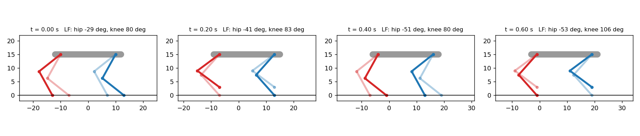
Figure 5.1: Mini-project output: four snapshots of the trotting quadruped (front legs blue, hind legs red, far-side legs faded).

5.3 Optional Hardware: 8-Servo Trotting Robot
Wire the PCA9685 to the board’s I²C pins (Uno: A4 = SDA, A5 = SCL; ESP32: GPIO 21 = SDA, GPIO 22 = SCL), power its servo terminal from the separate supply and join all grounds. Install the Adafruit PWM Servo Driver Library from the Library Manager. Before the robot touches the ground, set every trim value so that a commanded θ₁ = 0° makes each thigh vertical, and check that each DIR sign makes all legs swing forward together. The sketch compiles with standard Arduino types; servo directions, horn positions and trim values depend on your build and must be calibrated.
// Optional hardware: 8-servo quadruped (hip + knee per leg) trotting in place-forward.
// Needs: PCA9685 16-channel servo driver (I2C), "Adafruit PWM Servo Driver Library".
#include <Wire.h>
#include <Adafruit_PWMServoDriver.h>
#include <math.h>

Adafruit_PWMServoDriver pwm = Adafruit_PWMServoDriver(0x40);
const float L1 = 10.0, L2 = 10.0; // cm - measure your own legs
const float S = 4.0, H = 2.5, h = 15.0; // smaller steps for a first test
const float T = 1.0, BETA = 0.5; // trot
// leg order: LF, RF, LH, RH ; channels for hip and knee servos
const int HIP_CH[4] = {0, 2, 4, 6};
const int KNEE_CH[4] = {1, 3, 5, 7};
const float OFFSET[4] = {0.0, 0.5, 0.5, 0.0}; // trot touchdown phases
const int DIR[4] = {1, -1, 1, -1}; // right-side servos mounted mirrored
int trim[8] = {0, 0, 0, 0, 0, 0, 0, 0}; // calibration in degrees

void setServo(int ch, float deg) { // 0..180 deg -> 500..2500 us
deg = constrain(deg, 0.0, 180.0);
float us = 500.0 + deg * 2000.0 / 180.0;
pwm.setPWM(ch, 0, (int)(us * 4096.0 / 20000.0)); // 50 Hz frame = 20000 us
}

bool legIK(float x, float z, float &t1, float &t2) { // radians, knee backward
float c2 = (x * x + z * z - L1 * L1 - L2 * L2) / (2 * L1 * L2);
if (c2 < -1 || c2 > 1) return false;
t2 = acos(c2);
t1 = atan2(x, -z) - atan2(L2 * sin(t2), L1 + L2 * cos(t2));
return true;
}

void footPath(float ph, float &x, float &z) {
if (ph < BETA) { x = S / 2 - S * ph / BETA; z = -h; return; }
float s = (ph - BETA) / (1 - BETA);
x = -S / 2 + S * (s - sin(2 * PI * s) / (2 * PI));
z = -h + H * (1 - cos(2 * PI * s)) / 2;
}

void setup() {
Serial.begin(115200);
pwm.begin();
pwm.setPWMFreq(50);
delay(500);
}

void loop() {
float t = millis() / 1000.0;
for (int i = 0; i < 4; i++) {
float ph = fmod(t / T - OFFSET[i] + 10.0, 1.0);
float x, z, t1, t2;
footPath(ph, x, z);
if (!legIK(x, z, t1, t2)) continue; // skip unreachable targets
// servo 90 deg = theta1 0 (leg vertical) and theta2 90 deg; adjust to your build
setServo(HIP_CH[i], 90 + DIR[i] * degrees(t1) + trim[2 * i]);
setServo(KNEE_CH[i], 90 + DIR[i] * (degrees(t2) - 90) + trim[2 * i + 1]);
}
delay(20); // update at about 50 Hz
}

5.4 Test Cases, Limitations and Extensions
Test | Action | Expected result
TC1 | Run the simulator for 2 cycles | No assertion error; body advances 2 × 12 = 24 cm
TC2 | Check LF snapshot at t = 0 | Hip ≈ −29°, knee ≈ 80° (foot at x = +3, z = −15)
TC3 | Watch diagonal pairs | LF moves with RH, and RF with LH
TC4 | Set S = 30 cm | Foot target (15, −15) is 21.2 cm away > 20 cm: assertion stops the program
TC5 | Change to crawl (β = 0.75, T = 2 s) | Three feet always on the ground; body speed 4 cm/s
TC6 | Hardware: robot held in the air | Legs trot in diagonal pairs without hitting each other

Limitations: the simulator is kinematic only — it ignores mass, forces, foot slip and balance, so a physically unstable gait can still look fine on screen. The hardware sketch uses open-loop timing with no sensors. Extensions: add turning with different left and right step lengths; add body sway from Lab 3 to the crawl; import the same leg model into the PyBullet simulator to see the effect of gravity; add an IMU to keep the body level on a slope.

6. Troubleshooting and Common Mistakes
Problem | Likely cause | Fix
IK returns NaN or crashes | Target outside the workspace (|cos θ₂| > 1) | Check reach before arccos; reduce S or raise h
All angles about 57× too big or small | Degrees and radians mixed | Use np.radians / np.degrees at the boundaries only
Leg bends the wrong way | Wrong IK branch or wrong servo direction | Use θ₂ > 0 for knee-backward; fix the DIR sign
Foot jumps at the end of the swing | Phase convention mismatch or β wrong | Use touchdown offsets everywhere; check φ < β
Robot drifts sideways or turns | Left and right step lengths differ, or trim errors | Calibrate trims; check S on both sides
Robot tips over during crawl | CoM outside the support triangle | Add body sway; widen the stance; lower β only for dynamic gaits
Robot slips or stamps | Foot speed not zero at touchdown | Use the cycloid swing; reduce speed
Board resets when legs move | Servos powered from the board | Separate ≥ 5 A supply; common ground
Hind legs move with the wrong pair | Offsets assigned to wrong legs | Re-check the gait table: trot pairs LF + RH and RF + LH

7. Assessment and Revision

7.1 Formula Sheet
Quantity | Formula
Leg FK | x = L₁ sin θ₁ + L₂ sin(θ₁ + θ₂); z = −L₁ cos θ₁ − L₂ cos(θ₁ + θ₂)
Leg IK (knee) | cos θ₂ = (x² + z² − L₁² − L₂²) ÷ (2L₁L₂)
Leg IK (hip) | θ₁ = atan2(x, −z) − atan2(L₂ sin θ₂, L₁ + L₂ cos θ₂)
Reach test | |L₁ − L₂| ≤ √(x² + z²) ≤ L₁ + L₂
Body to hip | p_foot,hip = p_foot,body − p_hip,body
Duty factor | β = stance time ÷ T
Leg phase | φ = (t ÷ T − offset) mod 1; stance if φ < β
Speed and stride | v = S ÷ (βT); stride = S ÷ β
Froude number | Fr = v² ÷ (g·h)

7.2 Short Conceptual Questions
- Give two advantages and two disadvantages of legs compared with wheels.
- Name the three joints of a 3-DOF quadruped leg and the motion each one produces.
- What is a support polygon? When is a standing robot statically stable?
- Why does inverse kinematics of a 2-link leg usually have two solutions?
- Why is a crawl gait statically stable while a trot is not?
- What does the duty factor tell you about a gait?
- Why should the foot’s speed be zero at lift-off and touchdown?
- Why does a symmetric crawling robot need body sway?
Answer key (brief): 1 — legs: rough terrain, separate footholds; wheels: faster, simpler. 2 — HAA (sideways), HFE (forwards/backwards), KFE (knee bend). 3 — the shape around the stance feet; stable if the CoM projection is inside. 4 — knee-backward and knee-forward reach the same point. 5 — crawl keeps ≥ 3 feet down; trot has only 2 (a line). 6 — the fraction of the cycle each foot is on the ground. 7 — to avoid slipping and impacts. 8 — without it the CoM lies on a diagonal edge of the support triangle (zero margin).

7.3 Numerical Problems with Worked Solutions
Problem 1. L₁ = L₂ = 10 cm, θ₁ = 10°, θ₂ = 40°. Find the foot. Solution: θ₁ + θ₂ = 50°; x = 1.736 + 7.660 = 9.397 cm; z = −9.848 − 6.428 = −16.276 cm.
Problem 2. Find the knee-backward IK for the target (−4, −16) cm. Solution: cos θ₂ = (16 + 256 − 200) ÷ 200 = 0.36, θ₂ = 68.90°; γ = atan2(−4, 16) = −14.04°; β = atan2(9.330, 13.600) = 34.45°; θ₁ = −14.04° − 34.45° = −48.49° (matches Lab 1).
Problem 3. Can a leg with L₁ = 10 cm and L₂ = 8 cm reach (12, −15) cm? Solution: r = √(144 + 225) = 19.2 cm > 18 cm, so no.
Problem 4. The RH hip is at (−10, −5, 0) cm. The foot target in the body frame is (−12, −5, −16) cm. Give the hip-frame target. Solution: (−12 + 10, −5 + 5, −16 − 0) = (−2, 0, −16) cm.
Problem 5. A trot uses S = 5 cm, T = 0.5 s, β = 0.5. Find the speed, stride length and swing time. Solution: v = 5 ÷ 0.25 = 20 cm/s; stride = 5 ÷ 0.5 = 10 cm; swing = 0.5 × 0.5 = 0.25 s.
Problem 6. Stance feet at LF (10, 7), LH (−10, 7), RH (−10, −7) (anticlockwise). Find the margin for CoM (−2, 1). Solution: edge LF→LH: d = 6.0 cm; LH→RH: d = 8.0 cm; RH→LF: d = [20(1 + 7) − 14(−2 + 10)] ÷ √(400 + 196) = (160 − 112) ÷ 24.41 = 1.97 cm. Margin = 1.97 cm (stable).

7.4 Practical Evaluation Checklist and Rubric
# | The learner can… | Done
1 | Name legs, joints and frames of a quadruped correctly | ☐
2 | Compute leg FK and IK by hand and in code; pass the round-trip test | ☐
3 | Generate and explain crawl and trot gait diagrams and speeds | ☐
4 | Compute stability margins and explain the effect of body sway | ☐
5 | Run the mini-project simulator and pass test cases TC1–TC5 | ☐

Criterion (4 marks each) | Excellent (4) | Good (3–2) | Needs work (1–0)
Concepts and terms | Correct and with examples | Minor slips | Confuses stance/swing or legs
Leg kinematics | FK/IK correct and verified | Small arithmetic errors | Wrong angle references or signs
Gaits and speed | Correct offsets, β, v | One error | Gait timing wrong
Stability | Correct margins, clear explanation | Partly correct | Margin not understood
Implementation and report | Code runs, evidence complete | Some evidence missing | Code does not run

Glossary
Term | Meaning in simple words
Abduction / adduction | Moving a leg sideways away from / towards the body (hip roll).
atan2 | Two-argument arctangent that returns an angle in the correct quadrant.
Biped / quadruped / hexapod | Robot with two / four / six legs.
Body frame {B} | Frame fixed to the robot body: x forward, y left, z up.
Body sway | Shifting the body so the CoM moves into the support polygon before a leg lifts.
Centre of mass (CoM) | The point where the robot’s total weight can be thought to act.
Central pattern generator (CPG) | Coupled oscillators that produce rhythmic leg timing.
Crawl (walk) | Slow gait lifting one leg at a time; statically stable when β ≥ 0.75.
Cycloid | Smooth curve used for swing trajectories; zero speed at both ends.
Duty factor (β) | Fraction of the stride period a foot spends on the ground.
Dynamic stability | Balance kept by motion and timing, not by a large support polygon.
Foothold | A place where a foot is put on the ground.
Froude number | Fr = v²/(g·h); compares walking speeds of different-sized legs.
Gait | Pattern of leg timing used to walk or run.
Gait diagram | Chart of each leg’s stance (black) and swing over time.
HAA / HFE / KFE | Hip abduction-adduction, hip flexion-extension, knee flexion-extension joints.
Hip frame {H} | Frame at a leg’s hip used for that leg’s kinematics.
IMU | Inertial measurement unit: sensor measuring body rotation and acceleration.
Inverse kinematics (IK) | Finding joint angles that place the foot at a target.
Law of cosines | c² = a² + b² − 2ab cos C; gives the knee angle in leg IK.
Phase offset | Time a leg touches down, as a fraction of the stride period.
Shank / thigh | Lower / upper segment of a leg.
Singularity | Pose (such as a straight leg) where the leg loses the ability to move the foot in some direction.
Stability margin | Shortest distance from the CoM projection to the support-polygon edge.
Stance / swing | Phase when the foot is on the ground / in the air.
Static stability | Robot stays up even if it stops: CoM inside the support polygon.
Step length (S) | Distance a foot moves relative to the body during stance.
Stride period (T) | Time for one complete leg cycle.
Support polygon | Shape enclosing all feet on the ground.
Trot / pace / bound | Gaits moving diagonal / same-side / front-or-hind pairs together.
Workspace | All points a foot can reach.

References
The books and papers below are standard sources on legged locomotion, gaits and quadruped robots; the software links point to official documentation for the free tools used in the labs.
[1]Raibert, M. H. (1986). Legged Robots That Balance. MIT Press.
[2]Siciliano, B., & Khatib, O. (Eds.). (2016). Springer Handbook of Robotics (2nd ed.). Springer. — Chapters on legged robots and locomotion.
[3]Alexander, R. McN. (2003). Principles of Animal Locomotion. Princeton University Press.
[4]Alexander, R. McN., & Jayes, A. S. (1983). A dynamic similarity hypothesis for the gaits of quadrupedal mammals. Journal of Zoology, 201(1), 135–152.
[5]Hildebrand, M. (1965). Symmetrical gaits of horses. Science, 150(3697), 701–708.
[6]McGhee, R. B., & Frank, A. A. (1968). On the stability properties of quadruped creeping gaits. Mathematical Biosciences, 3, 331–351.
[7]Ijspeert, A. J. (2008). Central pattern generators for locomotion control in animals and robots: A review. Neural Networks, 21(4), 642–653.
[8]Hutter, M., et al. (2016). ANYmal – a highly mobile and dynamic quadrupedal robot. Proc. IEEE/RSJ IROS, 38–44.
[9]Katz, B., Di Carlo, J., & Kim, S. (2019). Mini Cheetah: A platform for pushing the limits of dynamic quadruped control. Proc. IEEE ICRA, 6295–6301.
[10]Kau, N., Schultz, A., Ferrante, N., & Slade, P. (2019). Stanford Doggo: An open-source, quasi-direct-drive quadruped. Proc. IEEE ICRA.
[11]Spong, M. W., Hutchinson, S., & Vidyasagar, M. (2020). Robot Modeling and Control (2nd ed.). Wiley.
[12]Lynch, K. M., & Park, F. C. (2017). Modern Robotics: Mechanics, Planning, and Control. Cambridge University Press.
[13]Stanford Student Robotics. StanfordQuadruped (Pupper) source code. https://github.com/stanfordroboticsclub/StanfordQuadruped
[14]Adafruit. 16-Channel PWM/Servo Driver (PCA9685) guide and library. https://learn.adafruit.com/16-channel-pwm-servo-driver
[15]PyBullet physics simulator. https://pybullet.org/
[16]NumPy and Matplotlib documentation. https://numpy.org/doc/stable/ and https://matplotlib.org/stable/
[17]Google Colaboratory. https://colab.research.google.com/

